Jacob Riis “How the Other Half Lives”

Jacob Riis was a famous progressive journalist who attempted to fix the social issues during the Gilded Age by shedding light on life for Americans living in extreme poverty. He did this through photography, which he compiled into a book called “How the Other Half Lives.” Most of the people he photographed were immigrants, as Riis himself was an immigrant.

Excerpt from Riis’s “How Other Half Lives”

The Italian in New York
The Italian comes in at the bottom. In the slums he is welcomed as a tenant who "makes less trouble" than the Irishman: is content to live in a pig-sty and lets the rent collector rob him. Ordinarily he is easily enough governed by authority—except for Sunday, when he settles down to a game of cards and lets loose all his bad passions. Like the Chinese, the Italian is a born gambler. His soul is in the game from the moment the cards are on the table, and very frequently his knife is in it too before the game is ended.

Chinatown
Red and yellow are the holiday colors of Chinatown, but they do not lend brightness in Mott Street. Rather, the colors only add a general dullness. Whatever happens in Chinatown goes on behind closed doors in stealth and secretiveness. His business, as his domestic life, shuns the light, less because there is anything to conceal than because that is the way of the man. The stranger who enters through the doorway is received with sudden silence, a sullen stare, and an angry "Vat you vant?" that breathes annoyance and distrust.

Jewtown
Poverty always goes along with dirt and disease, and Jewtown is no exception. The diseases these people suffer from are not due to intemperance or immorality, but to ignorance, want of suitable food, and the foul air in which they live and work. The homes of the Hebrew quarter are its workshops also. Every member of the family, from the youngest to the oldest, works, shut in the stuffy rooms, where meals are cooked and clothing washed and dried besides, all day long. It is not unusual to find a dozen persons--men women, and children--at work in a single small room. It has happened more than once that a child recovering from small-pox, and in the most contagious stage of the disease, has been found crawling among heaps of half-finished clothing that the next day would be offered for sale on the counter of a Broadway store.

Source: Excerpts from Jacob Riis’s book How the Other Half Lives, 1890. Jacob Riis was a “muckraker” who photographed poverty in New York City’s slums in the 1880s.

Questions:
- Who wrote this? What type of document is this?

- What was the author’s purpose in writing this?

- Who do you think Riis’s audience was? Explain.

- How did many Americans view immigrants at this time? Why did they view them that way?

- What is the author trying to make you feel? Describe what you feel after reading about the immigrant’s experiences in this country.

- What are his attitudes towards poverty? What are his attitudes towards these immigrants?

- Jacob Riis was someone who thought he was helping the immigrants and supporting them. How could he think that if he wrote texts like this?

Picture responses:

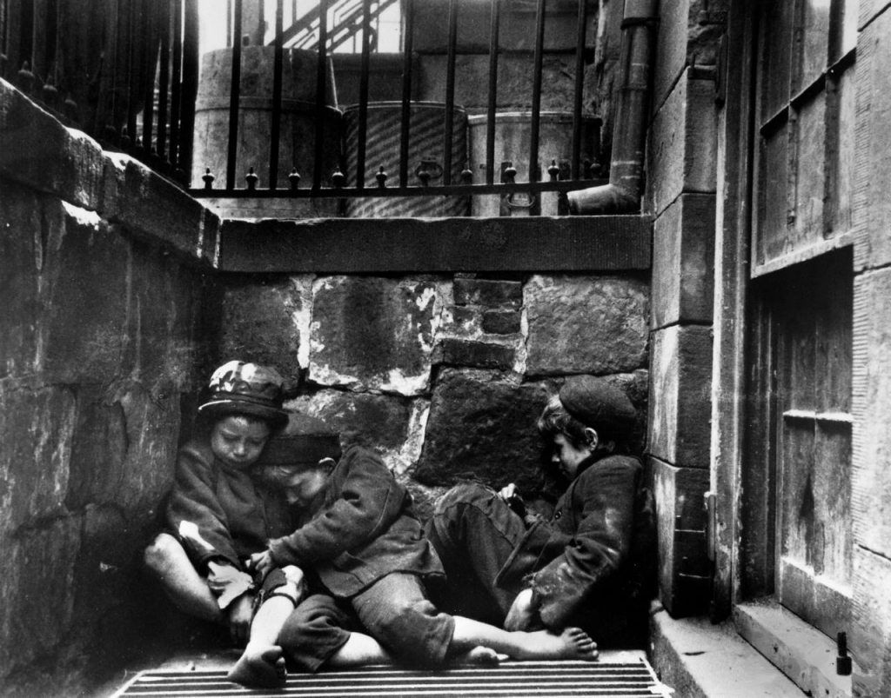

- Describe what type of conditions these children are living in.
- Why do you think Riis chose to have children as the subject of this photo?
- What do the expressions on the faces of these children tell you about their lives?
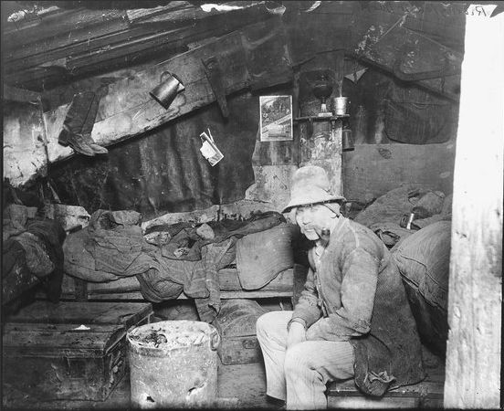

- The title of this photo is “Under the Dump.” What does this photo show you about where people lived?
- Would you classify this man as a member of the working class or urban poor? Why?
- What do you think the rest of America thought of these photographs?
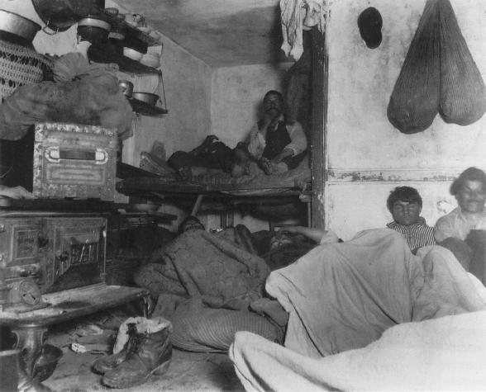

- What types of homes were these people living in?
- Do you think these photographs are trustworthy accounts of what life was like in American cities during the Industrial era? Why or why not?
- What do you think Riis wanted to communicate to his audience?

