How the Klan Fueled Prohibition
The 1920s weren’t just gin joints and jazz. Anti-immigrant racism was all the rage.
By Lisa McGirr
Ms. McGirr is a professor of history at Harvard and the author of “The War on Alcohol: Prohibition and the Rise of the American State.”
- Jan. 16, 2019 – New York Times
Disposing of confiscated beer during Prohibition.
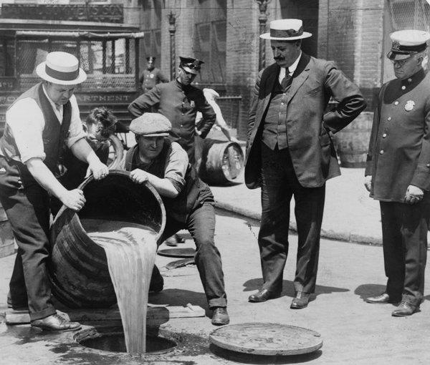
Disposing of confiscated beer during Prohibition.
On Jan. 16, 1919, Nebraska became the 36th state to ratify the 18th Amendment to the Constitution, which banned the manufacture, sale, import or transportation of intoxicating liquors. The Prohibition era had begun.
Prohibition looms large in the national imagination even today as the era of gangsters and gin joints. Less often do we reflect on what motivated the country to adopt it and maintain it for 14 years. While the country faced a real problem of excessive drinking, powerful anti-immigrant hostility is what drove this monumental act of constitutional overreach.
Today, as we find ourselves in the midst of another fight over immigration, it is worth revisiting the role that nativism played in driving, and later enforcing, Prohibition. The consequences of that battle reverberated for decades to come. It sparked a vast expansion of the repressive capacities of the federal government and a rise of right-wing extremism, led by a revived Ku Klux Klan. It also forged a new political coalition that would bring ethnic working-class voters into the Democratic Party, where they would remain for much of the century.

Opinion | Susan Schulten
How Prohibition Shaped Harlem
In 1932, a pioneering illustrator captured the way America’s ban on booze created a more urbane night life culture in Manhattan.
Jan. 16, 2019
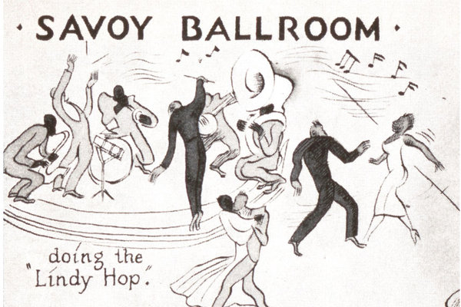

Temperance and Prohibition had been popular causes throughout the 19th century, but supporters didn’t reach a critical mass until the era of mass immigration at the turn of the century. With more than a million men and women coming to the United States in 1907 alone, anti-liquor crusaders railed against a “foreign invasion of undeveloped races.” The boisterous drinking culture of the ubiquitous working-class saloon, dominated by immigrant men, seemed to make manifest the dangers mass immigration posed to a white native Protestant American way of life.

During World War I, the Anti-Saloon League, the self-declared Protestant Church in action, fanned nativist flames: With the large brewing companies in the hands of German immigrants, the league declared the abolition of “the un-American,” “home wrecking, treasonable liquor traffic” the most patriotic act. Congress concurred, sending the 18th Amendment to the states on Dec. 22,1917.
Ratification sped through the states in record time, stunning its ecstatic supporters: “The rain of tears is over. … Hell will be forever for rent,” the flamboyant evangelical preacher Billy Sunday proclaimed. The Women’s Christian Temperance Union, the powerful grass-roots female reform organization at the core of the anti-liquor crusade, raised an American flag at its campaign headquarters in Evanston, Ill. Church bells rang at many Protestant churches in celebration of “Uncle Sam’s knockout blow … that set John Barleycorn and all his cohorts to the mat.”
The utopian hopes of Billy Sunday and his ilk that the 18th Amendment would turn “our prisons into factories” quickly evaporated. The vast and powerful federal agencies in charge of policing Prohibition as of January, 1920, along with state and local enforcement, overcrowded court dockets, changed legal doctrine and flooded prisons, but they did little to meet Prohibitionists’ almost impossible ambitions.
Newly hired and poorly trained Prohibition agents, along with local and state police, targeted violators at the margins, but they lacked the capacity, and at times the will, to go after powerful crime kingpins. Chicago’s Al Capone, Ohio’s George Remus, New York’s Arthur Rothstein and Seattle’s Roy Olmstead amassed large fortunes in the profitable illicit drink trade, oiling their violent supply rings with payoffs to judges, senators and officers on the beat.
At the same time, a small group of affluent, urban, pace-setting adventurers rebelled against the law in subterranean night-life spaces, sparking innovative dance styles and providing new audiences for the experimental sounds of jazz. Prohibition’s cultural earthquake, centered in the mixed-sex and mix-raced night-life venues in cities like New York and Chicago, reverberated in smaller towns and cities through Hollywood movie plots, tabloid newspapers and radio.

It was, according to one New York opponent, a cultural “civil war.” In 1922, President Warren Harding declared the lack of observance a national scandal. The men and women who had worked so hard for the law’s passage feared a vicious conspiracy to discredit and overthrow Prohibition. Anxieties over immigration, urbanization and the erosion of the cultural dominance of Anglo-Saxon Protestantism swelled even further in face of a new spirit of self-expression.
With Prohibition newly enshrined in the Constitution, anti-liquor crusaders demanded better, stricter enforcement and harsh punishment for violators. Roy Haynes, the federal Prohibition commissioner, blasted the “dry rot” and evil influences that had to be “torn out” by citizens militant in the law’s defense. A volunteer enforcement army coalesced. The Anti-Saloon League and the Women’s Christian Temperance Union forged two of its phalanxes, adopting an increasingly shrill tone toward immigrants. Compliance among this “great problem” class required coercion, with “officers of the law” acting as “schoolmasters.” The W.C.T.U. in 1923 called for the deportation of noncitizens convicted of Prohibition violations. Despite evidence that foreigners were less likely than native-born Americans to violate the law, anti-liquor crusaders marshaled alternative facts: “Seventy-five percent of liquor law violators are foreigners,” the Indiana W.C.T.U falsely claimed.

Anti-liquor crusaders found a powerful new ally in the so-called second Ku Klux Klan.

As enforcement failures multiplied, anti-liquor crusaders found a powerful new ally in the so-called second Ku Klux Klan. Established in 1915 by William Simmons in Atlanta, the organization snowballed after 1920 in the Midwest and West. Its savvy promoters, Elizabeth Tyler and Edward Young Clarke, former fund-raisers for the Anti-Saloon League, drew in a bumper crop of new recruits with their anti-Catholic, anti-immigrant, white supremacist message.
Other forms of postwar social conflict aided the growth of the Klan, but nothing did more than the 18th Amendment to turn it into a dynamic social movement. The Klan and its female affiliate, the Women of the Ku Klux Klan, recruited heavily from the nation’s white Protestant Prohibition organizations, promising militant action to ensure the law’s enforcement. Not surprisingly, the Klan targeted the drinking of those they identified as enemies of “100 percent Americanism” — Catholics, foreigners and African-Americans — and often gained a foothold in white Protestant evangelical communities with its promise to put bootleggers and moonshiners out of business. If officers of the law could not or would not do their duty, the Klan vowed to step in, often with the support of the local government.
The actions of the citizen Prohibition army in Williamson County, Ill., a hardscrabble rural mining region 300 miles south of Chicago, provides a striking example. The head of the Williamson County board of supervisors and a local Klan leader, Sam Stearns, and a Methodist pastor and Klan ally named Philip Glotfelty, along with members of the local Ministerial Association, had high hopes that Prohibition would usher in a new moral tenor in their community. Before Prohibition, the region’s largely native white Protestant miners might stop for a whiskey after a hard day’s work in the ramshackle bars that dotted the county, ignoring their pastors’ warnings against the “devil’s drink.” In Prohibition’s wake, drinking continued in new roadhouses and moonshine joints. Two rival criminal rings, the Birger and Shelton gangs, set up shop to supply the thriving black-market trade.
Glotfelty and Stearns, backed by the county’s leading businessmen and Protestant pastors, mounted a law and order crusade. They held public meetings to raise the alarm. Italian and French immigrants, largely Catholic, had been drawn to Williamson County by opportunities to work in the coal industry, and Glotfelty blamed the men “imported from across the sea” for bootlegging. He confidently predicted that all members of the local Catholic church would be in jail before “the foundations of the new church were built.”
Glotfelty’s words resonated among the region’s native white Protestant miners, whose tenuous hold on economic security was increasingly eroding. A strike to protest wage cuts had ended in open class warfare in 1922. Williamson County’s moral leaders focused native Protestant miners’ grievances on another threat: the immigrants who competed for mining jobs. The local Klan ranks swelled with the promise to “clean up” the community.
Representing the Klan, Stearns traveled to Washington to plead for support for its local anti-liquor crusade. Commissioner Haynes agreed to supply federal agents to lead the raids if Stearns could provide the foot soldiers. On Dec. 22, 1923, the first raid, in the town of Herrin, got underway. Some 500 citizen volunteers deputized by Haynes’s agents stormed scores of roadhouses and homes. A second raid two weeks later overwhelmingly targeted Italian immigrants, who protested rough treatment, theft and planted evidence.
The Italian vice-consul in Springfield, Ill., denounced the “terrorization of foreign residents of Herrin” to the State Department. National Guard troops were called in to stem the chaos and violence. Eventually, the federal government ended its authorization for the volunteer army, refusing “reinforcements from the Ku Klux Klan or any other volunteer organization.”
But the citizen army was not easily deterred. Stearns gleefully declared, “We’ve got the bootleggers on the run now, but we want to give them their hats, so they can keep on running.” Over the following months several more raids, each increasingly reckless, targeted Williamson County’s immigrants. On Feb. 2, 1924, S. Glenn Young, a former Prohibition agent who had been recruited by the Klan, led more than 1,000 men in raids against roadhouses and homes, setting fire to some of them. This time the county’s French immigrant community joined the Italian immigrants pleading for help from their consul. With Klan and anti-Klan forces battling in the streets, the Illinois governor declared martial law.
The orgy of violence resulted in 14 deaths, but it also eroded Klan support among the public. Klan candidates had swept into office in Herrin in 1924, but one year later they lost power. The newly elected mayor promised to bar Klan supporters from parading in masks. But before the collapse of its power, the local Klan had partially accomplished its goals: More than 50 roadhouses and illicit drink spaces had been shut, and many of Williamson County’s immigrants heeded the Klan’s call to leave the county. Of the 11,000 foreign born and their children in 1920 in Williamson County, only 8,174 remained a decade later.
The mobilization of Prohibition’s citizen’s enforcement army in Williamson County was replicated on smaller scales in many towns and cities. From Orange County, Calif., to Birmingham, Ala., the Klan buttressed local police in anti-liquor raids, targeting groups they perceived as enemies of “100 percent Americanism.”
That campaign of terror was one of the law’s most devastating consequences. But immigrants and their children also despised the criminalization of their cultural rituals and leisure habits, the violence that illegal supply rings brought to their neighborhoods and the selective enforcement that disproportionally targeted poor violators. One Chicago immigrant leader summed up the passionate sentiments of many, blasting Prohibition as the “most vicious and tyrannical piece of legislation enacted anywhere in the world.”

Al Smith, running for president in 1928, attracted large numbers of urban, white ethnic voters to the Democratic Party for the first time with his anti-Prohibition message.

The battles over Prohibition erupted in the 1928 presidential election. The Irish Catholic governor of New York, Al Smith, ran for president on the Democratic ticket opposing the law and championing tolerance. Smith attracted large numbers of urban, white ethnic voters to the party for the first time, along with a small segment of African-Americans. Though Herbert Hoover won handily, the ethnic, urban, industrial working class Smith brought to the party stayed there, forging an important part of Franklin Roosevelt’s New Deal coalition. One of Roosevelt’s first acts in office was to sign the beer bill, re-legalizing the industry in March of 1933, pending the repeal of national Prohibition.
ADVERTISEMENT
Roosevelt adopted creative solutions to the Great Depression, building on the new federal authority and resources won during the war on alcohol. Prohibition, as elite conservative critics had rightly feared, cracked the door open toward other forms of regulation. Not only did Prohibition forge the edifice of the federal penal state, but growing numbers of Americans looked to the federal government for solutions to social and economic problems.
One Roosevelt supporter summed up this logic when he called for a four-day week at a six-day wage when he wrote to the presidential candidate: “the Eighteenth Amendment made it possible for the government to take over enforcement of Prohibition. Surely, capable leaders could soon get another amendment to the Constitution passed that would empower Congress to shorten the work day for all labor throughout the nation.”
Prohibition had lasted less than 15 years, but its legacies outlasted its repeal and achieved almost the opposite intended by its most ardent supporters. Hoping to make liquor less desirable by shutting saloons, the anti-liquor crusaders ushered in the mixed-sex, alcohol-laced, night-life leisure Americans have known ever since. The ban did not end crime and corruption, as the crusaders claimed it would, but drove it to higher levels, leading to a new and permanent role for the federal government in crime control.
And Prohibition’s titanic overreach led to the enfranchisement of new immigrant groups under the banner flag of Prohibition opposition. The era’s heightened nativism had not cowed Americans immigrants, their children or their allies. Instead they reached out for a fuller place in national political life to forge a more pluralist, tolerant, equitable country. The tyranny of Billy Sunday and his ilk proved short-lived.
Lisa McGirr is a professor of history at Harvard and the author of “The War on Alcohol: Prohibition and the Rise of the American State.”

